

**Computer Networks**

**Company Name:**

***“****Futurenostics****”***

**Prepared By:**

| Name | Roll Number | Email Address |
| --- | --- | --- |
| Muhammad Ali | 241383 | 241383@students.au.edu.pk |
| Zain ul Abideen | 241475 | 241475@students.au.edu.pk |
| Ayesha Siddiqa | 241419 | 241419@students.au.edu.pk |

**Submitted To:**

Mam Amna Sarwar

Email: amna.sarwar@students.au.edu.pk

# **PCs:**

## **Static one ;**

### **HeadQuarter**

**Management vlan 10**

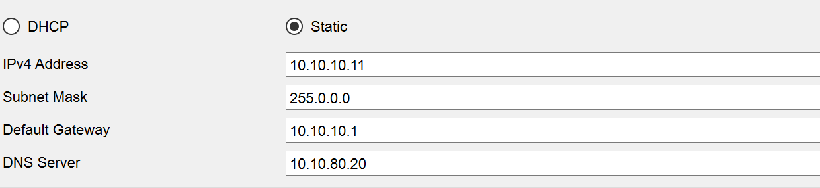

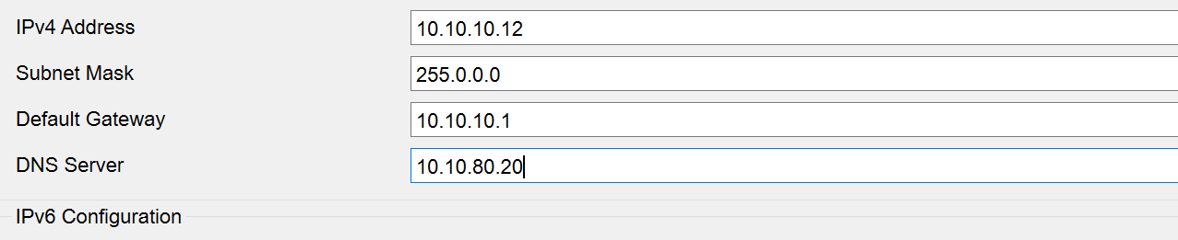

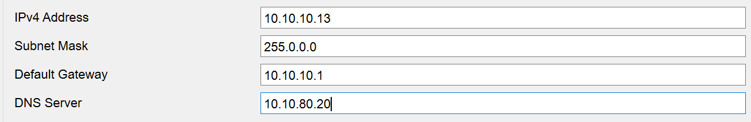

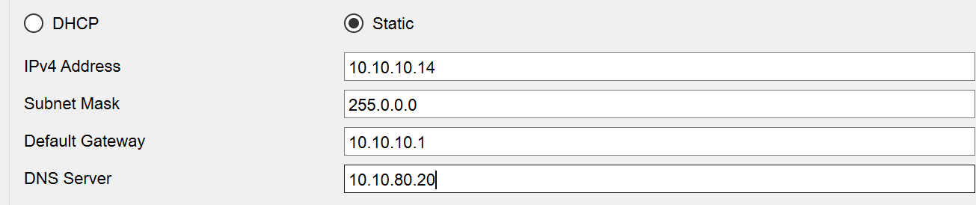

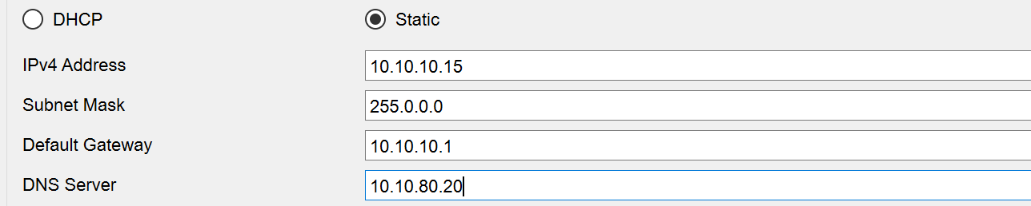

**Development valn 20**

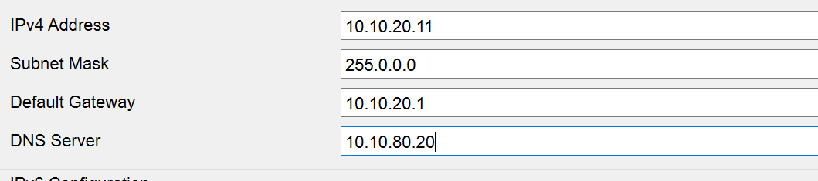

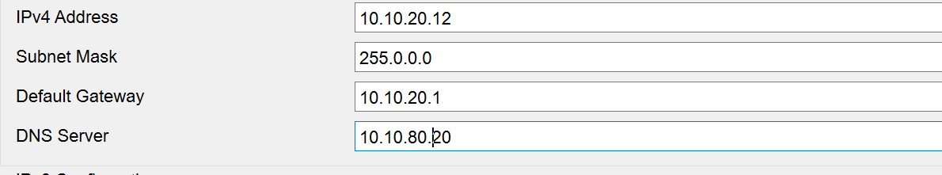

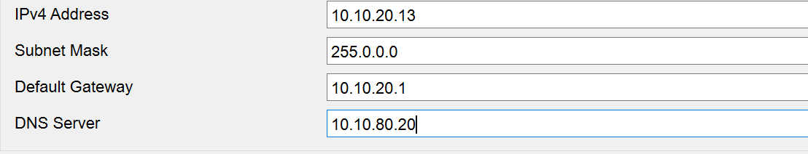

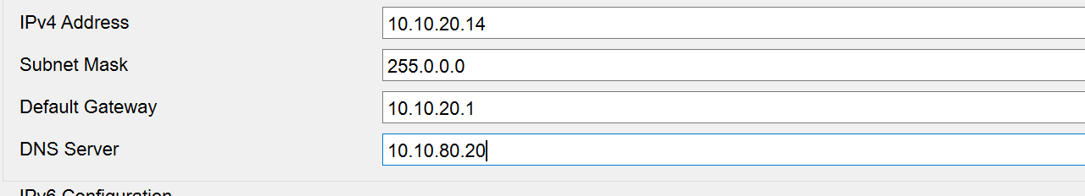

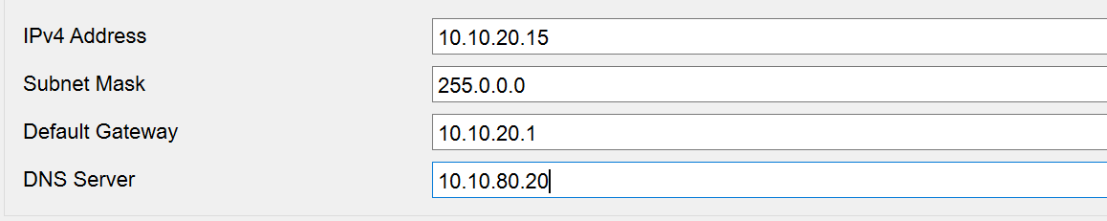

**Business vlan 30**

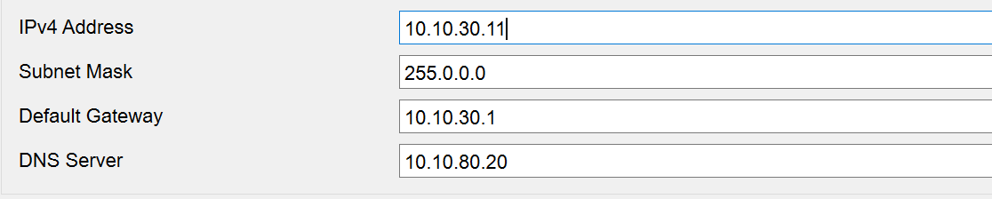

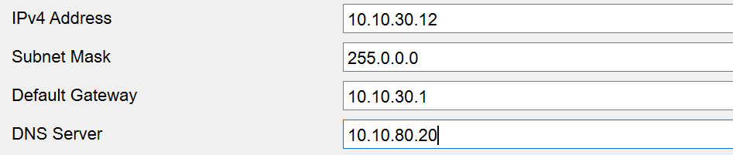

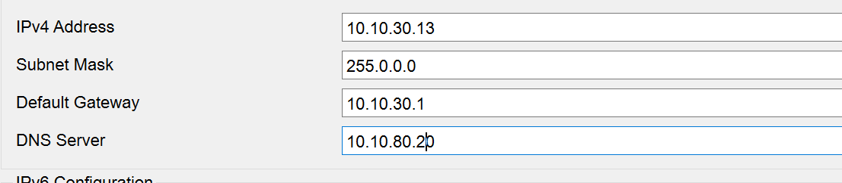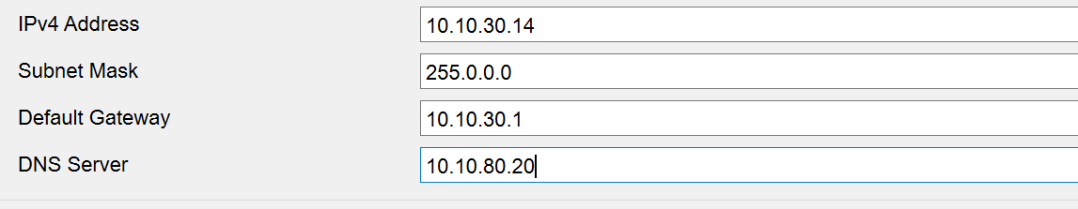

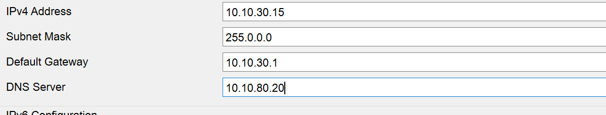

**HR vlan 40**

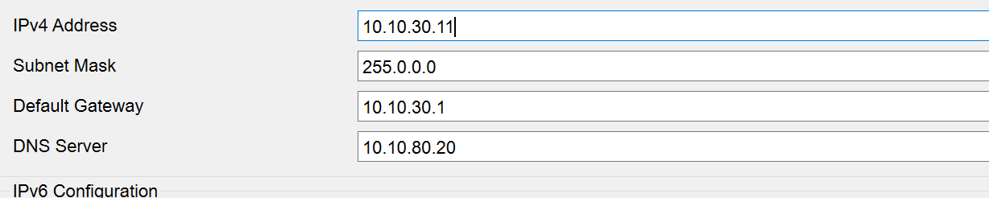

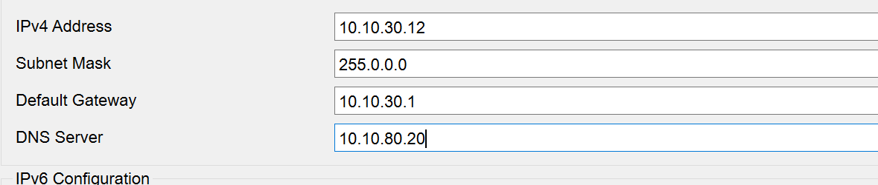

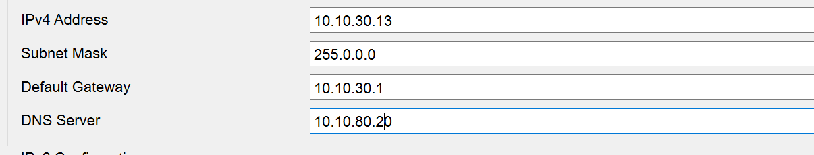

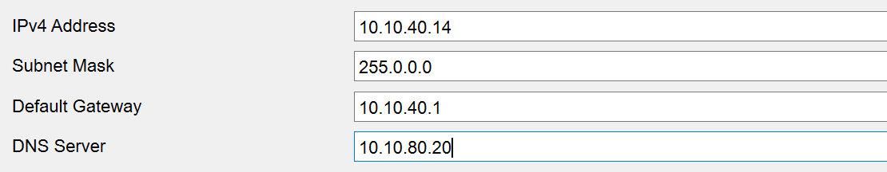

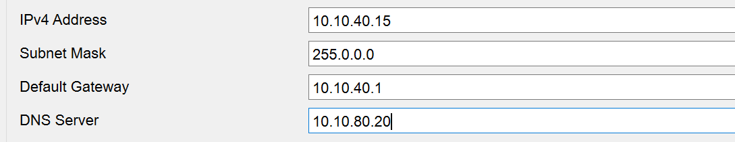

**Finance vlan 50**

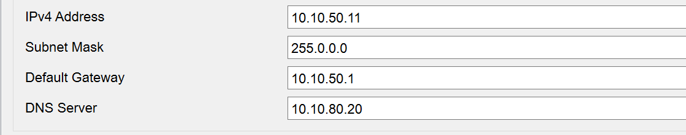

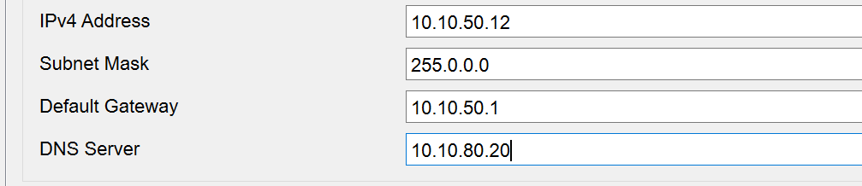

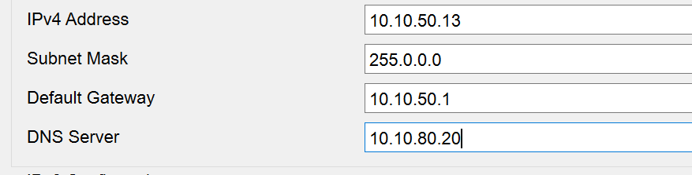

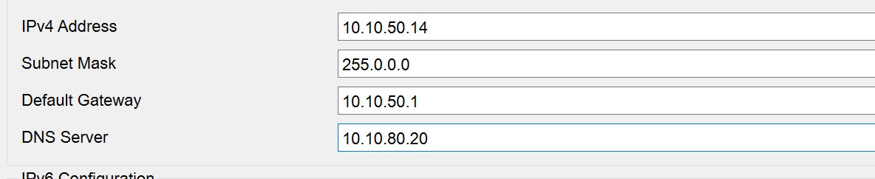

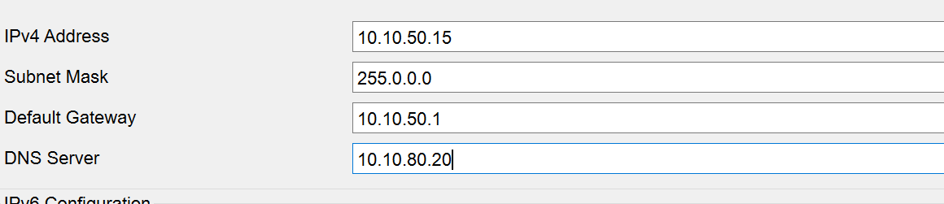

**Netowrking vlan 60**

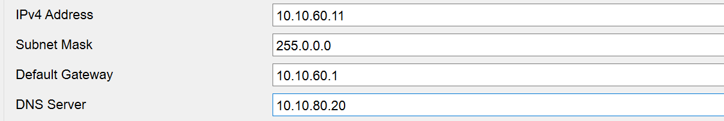

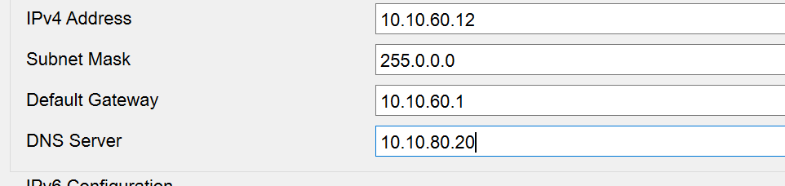

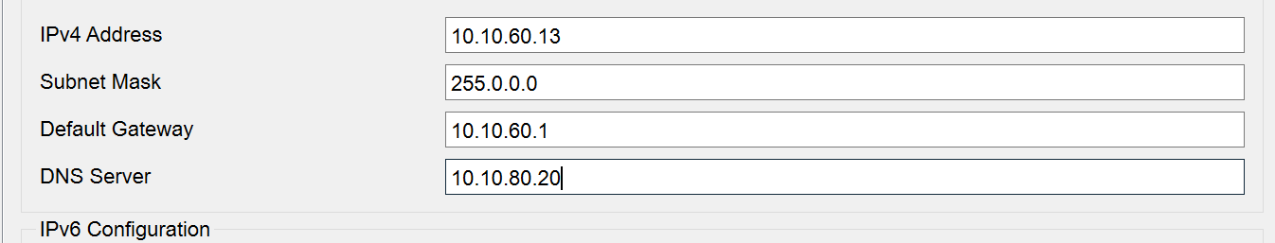

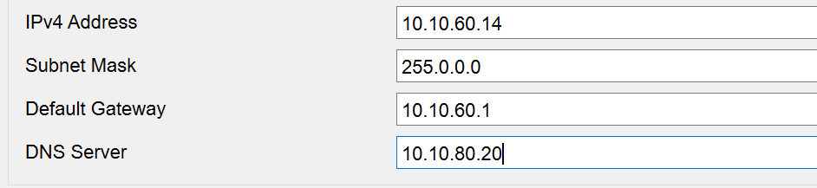

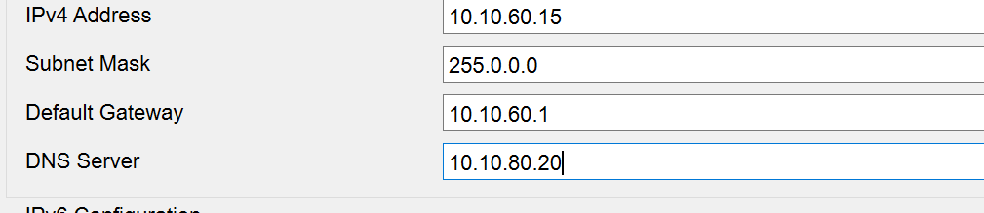

**CCTV vlan 70**

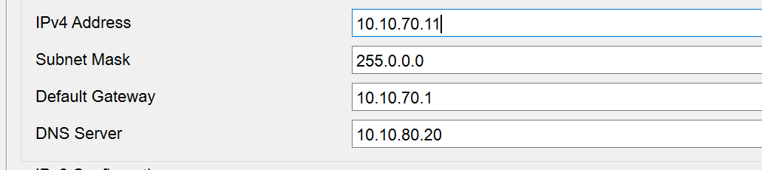

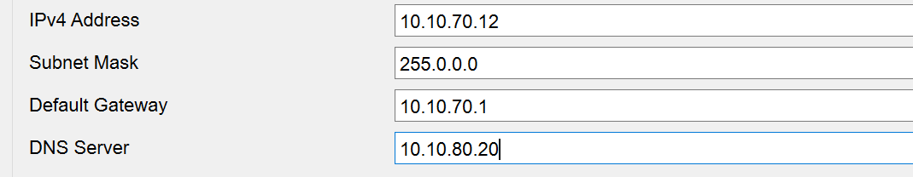

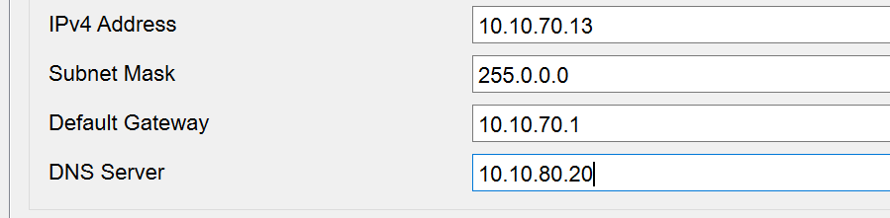

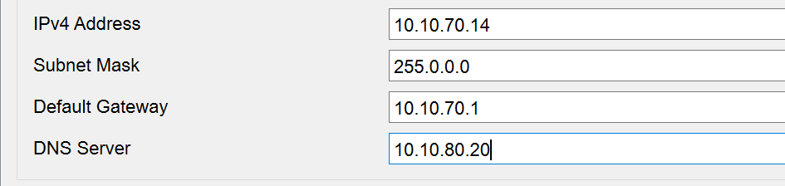

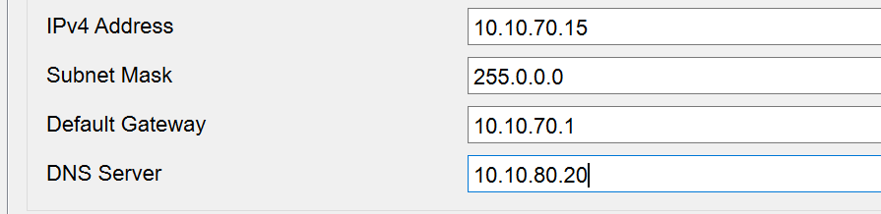

**Guests vlan 90**

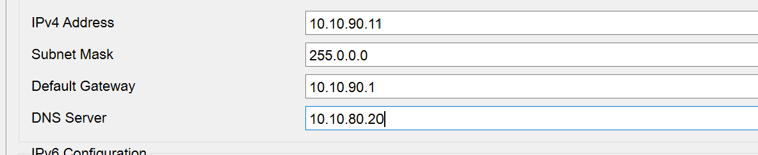

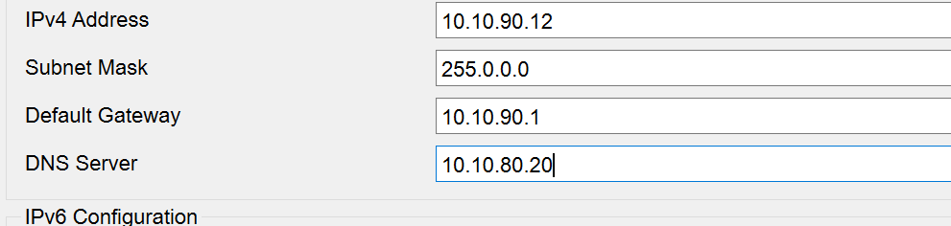

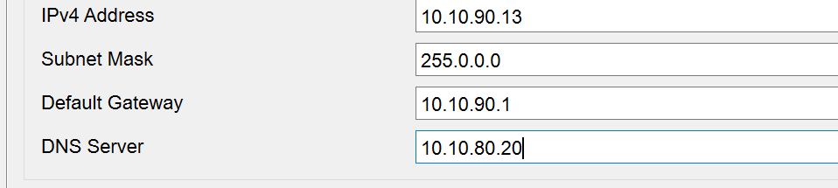

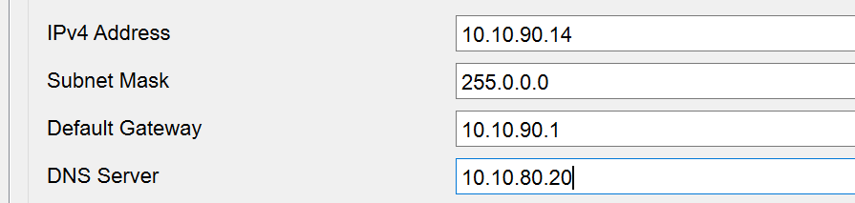

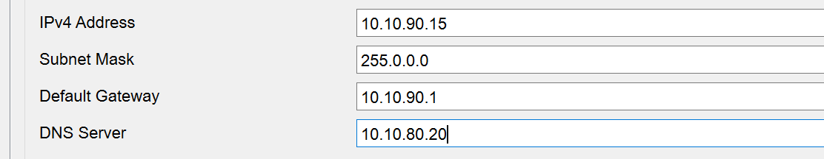

### **Branch A**

**Development vlan 20**

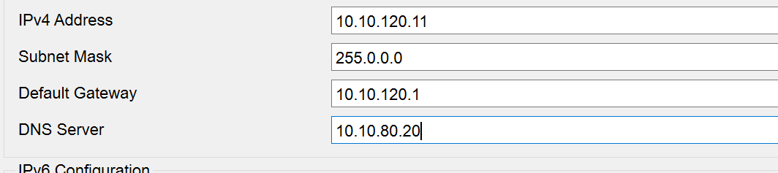

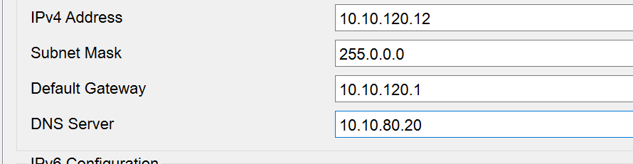

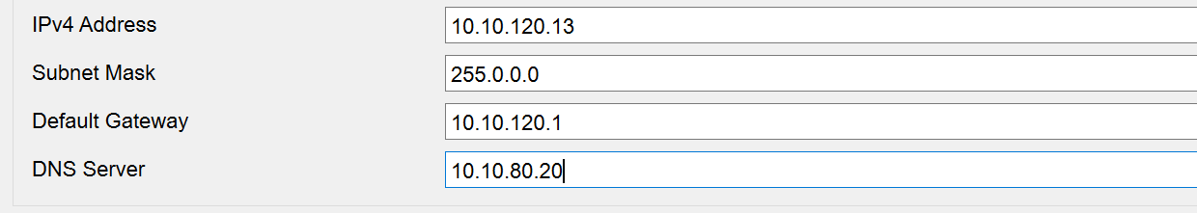

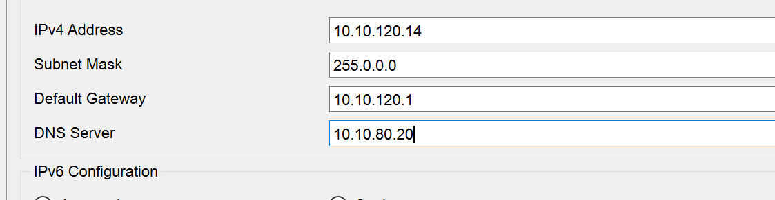

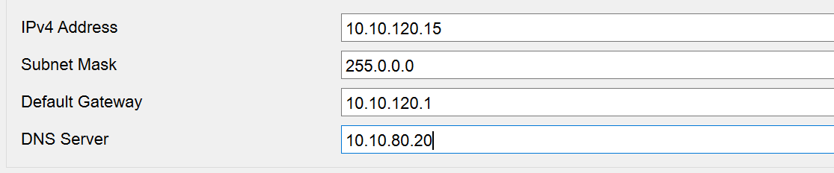

**Business vlan 30**

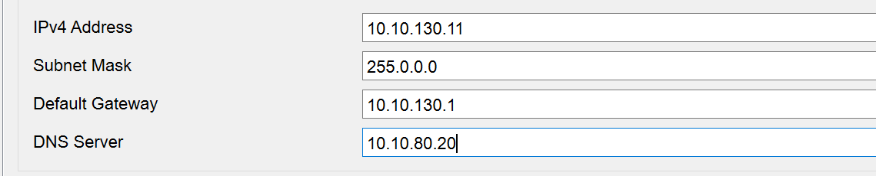

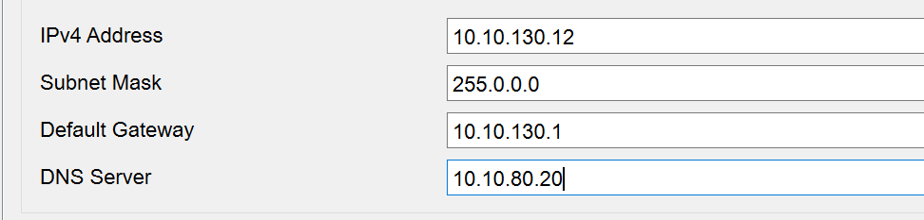

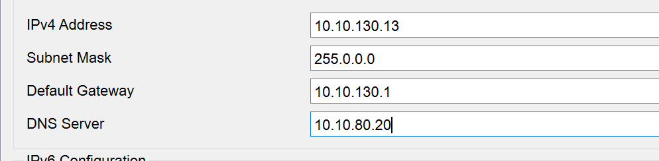

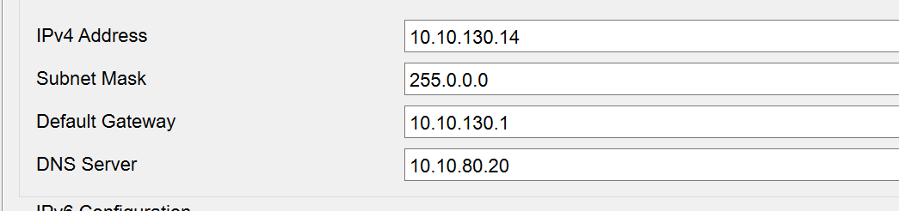

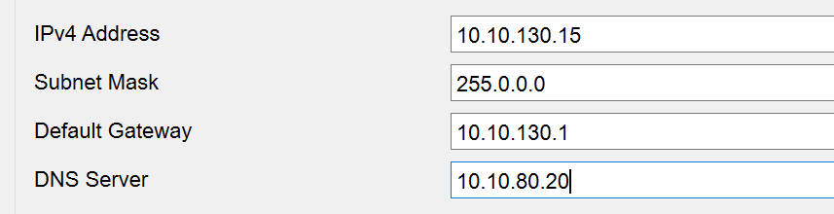

**Networking vlan 60**

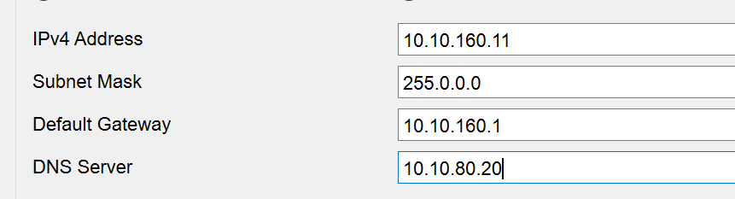

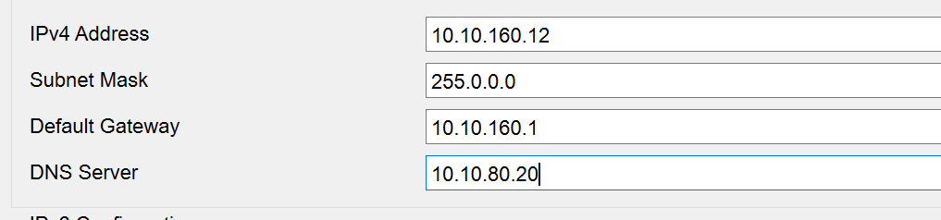

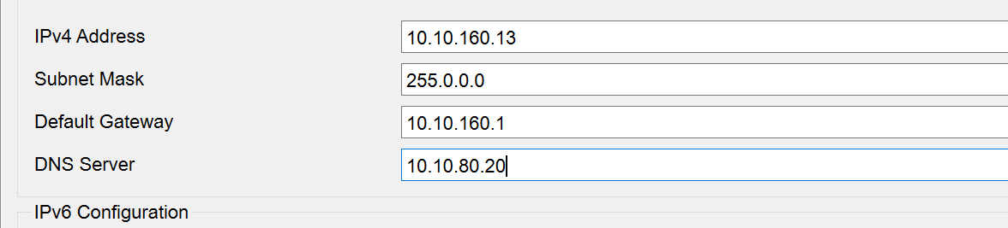

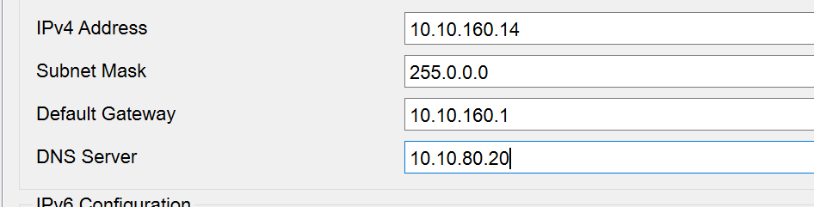

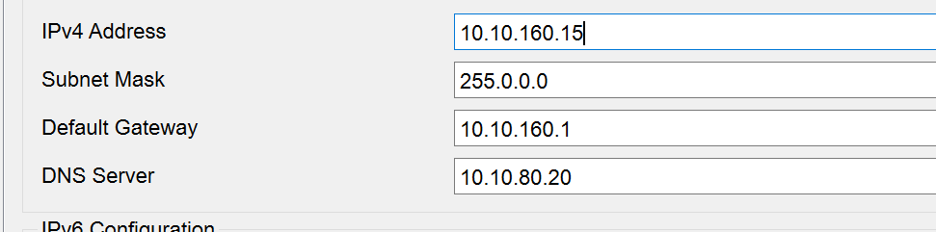

**CCTV valn 70**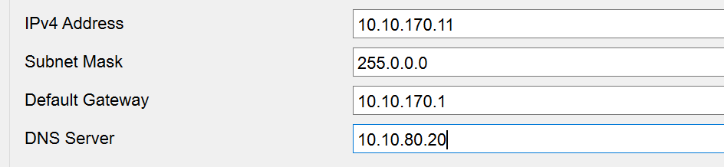

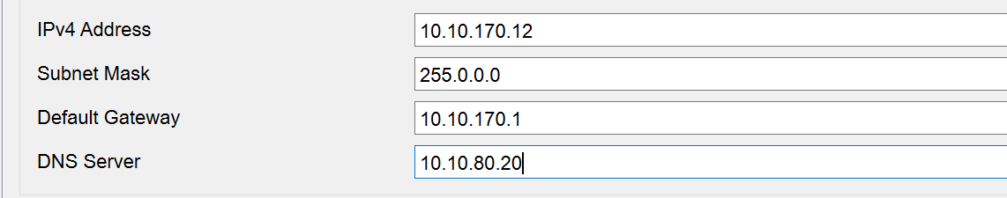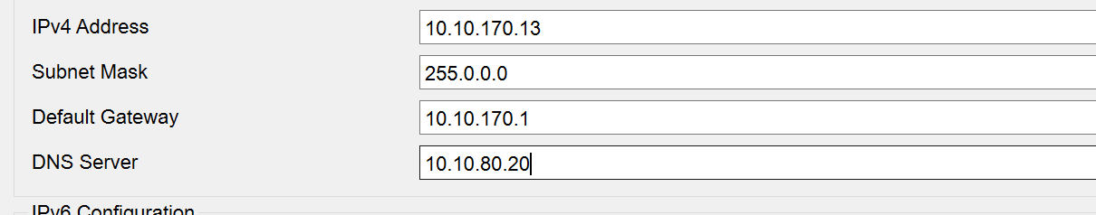

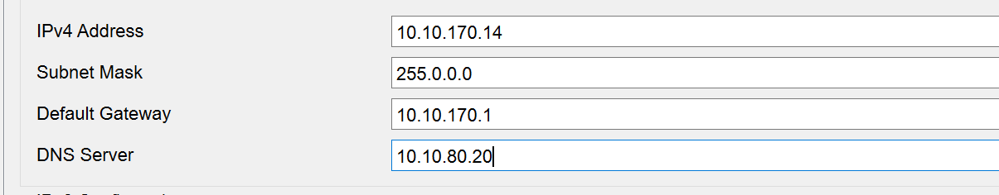

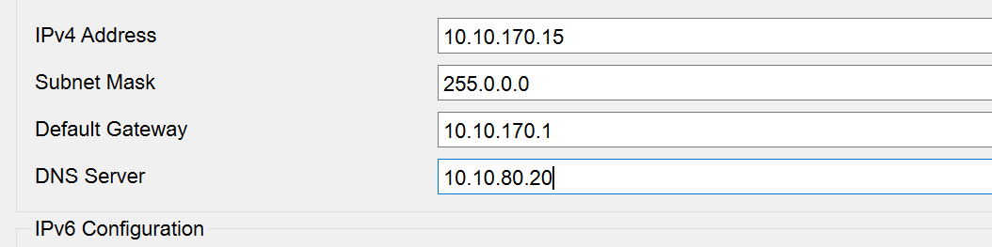

### **Branch B**

**Management vlan 10**

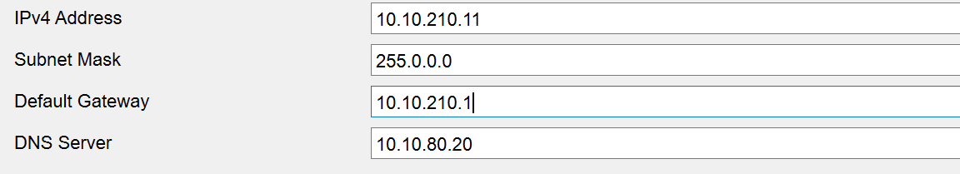

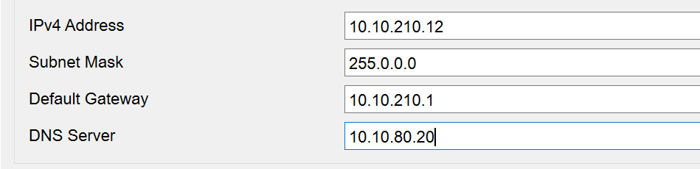

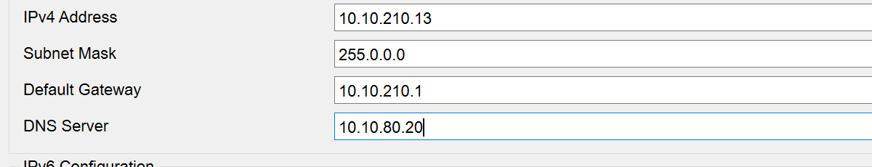

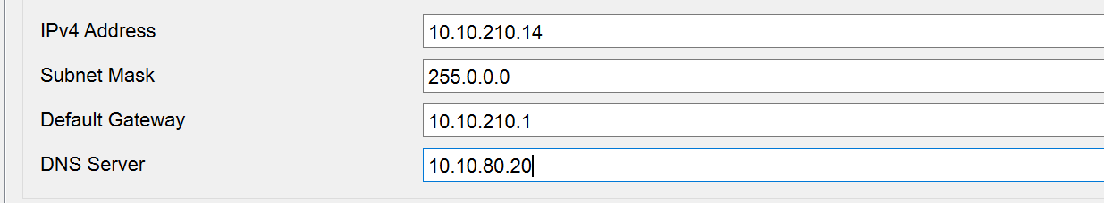

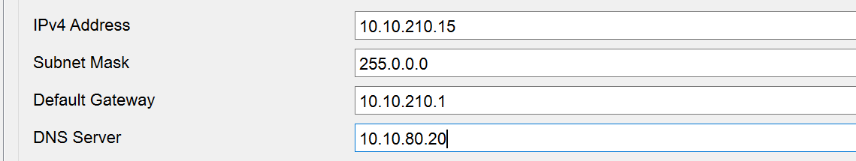

**Development valn 20**

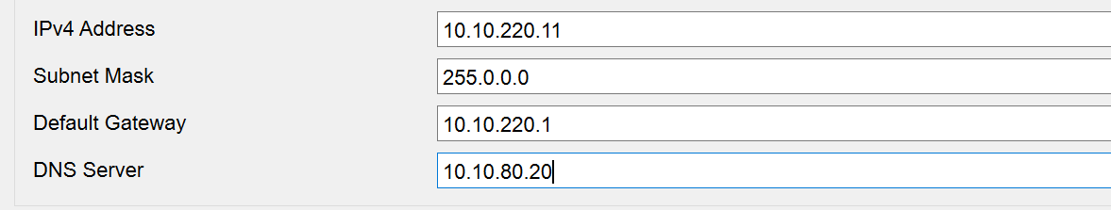

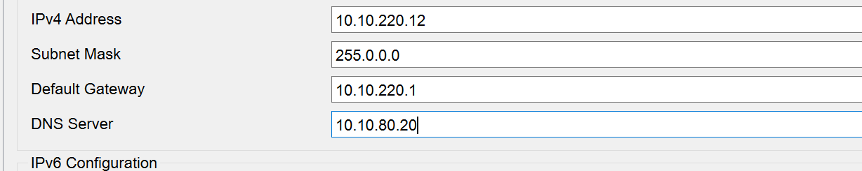

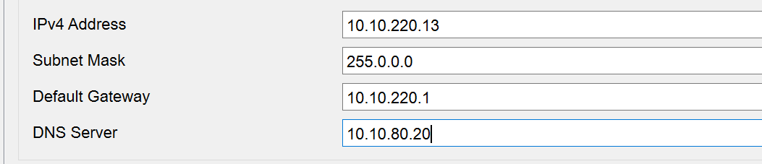

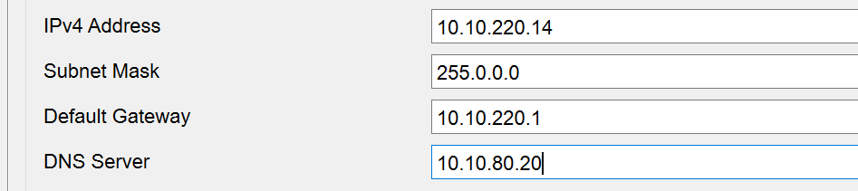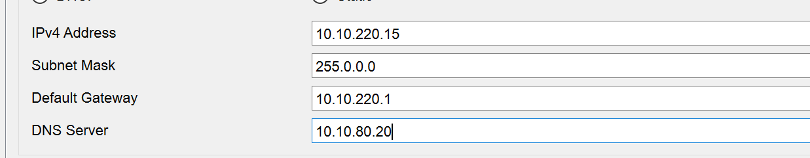**Business vlan 30**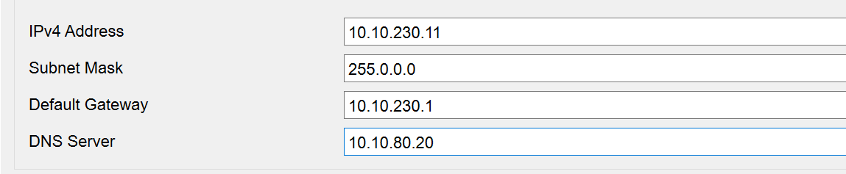

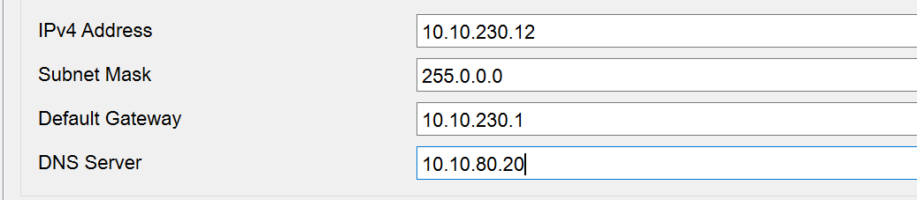

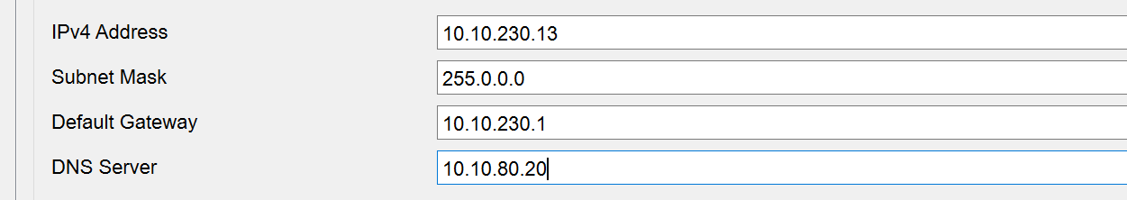

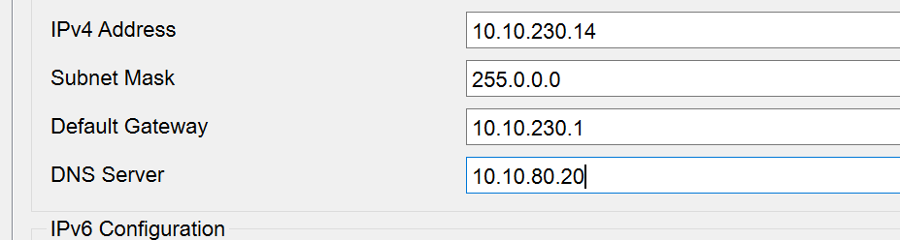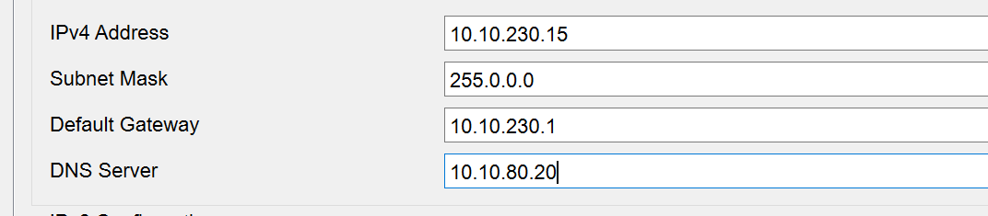**Finance vlan 50**

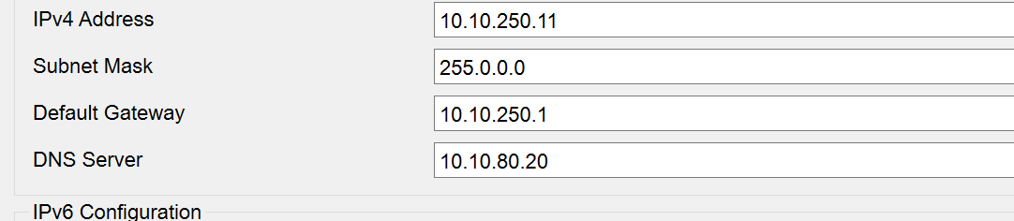

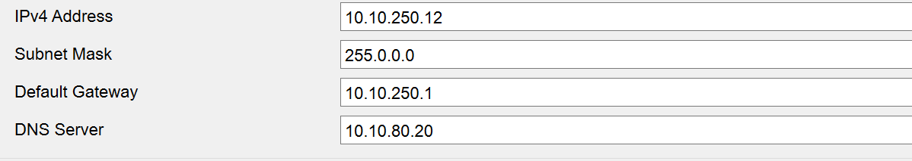

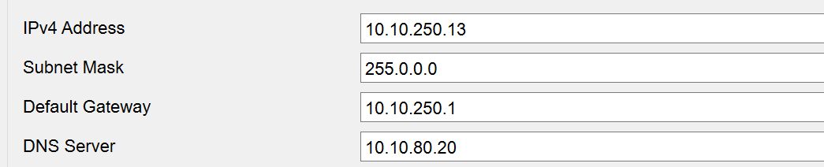

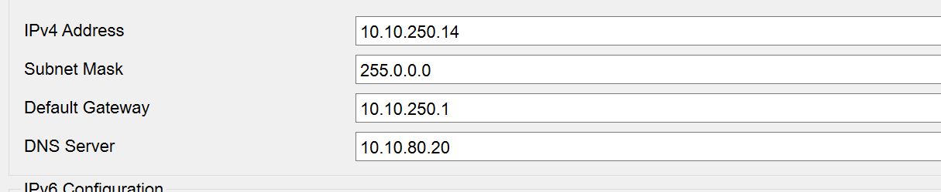

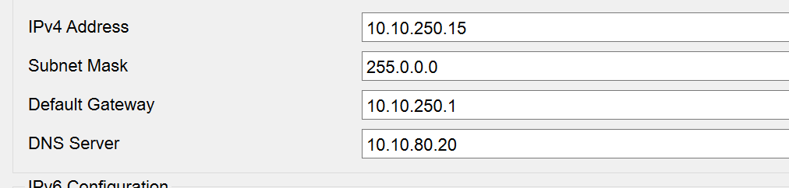

**Networking vlan 60**

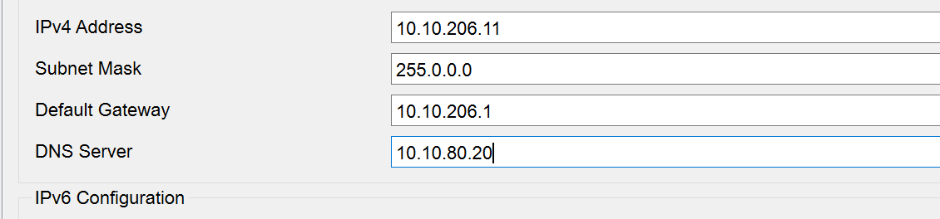

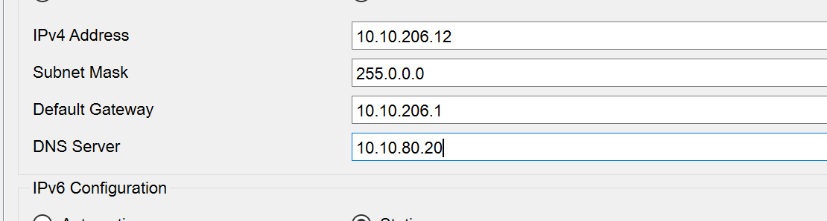

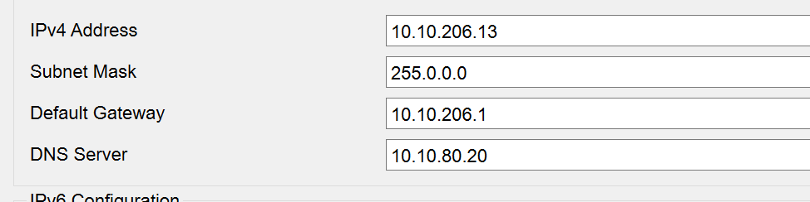

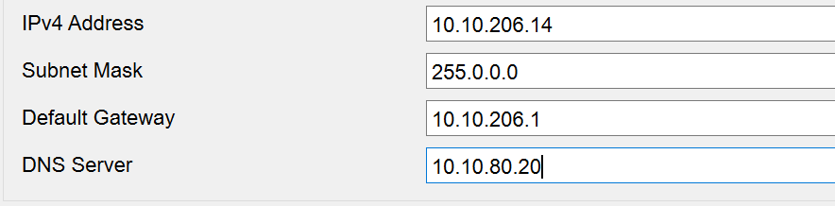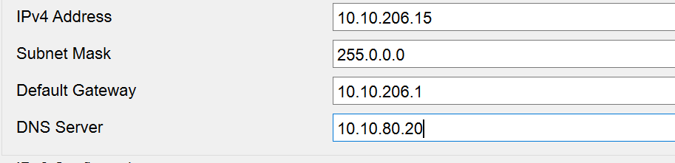

# **Routers IP addressing:**

**Branch A:**

## **BA-Edge (router 2911)**

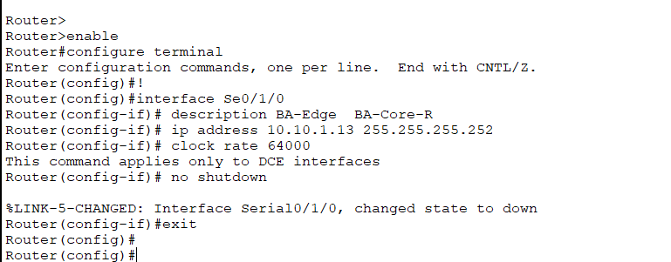

## **BA-Core-R (router 2911)**

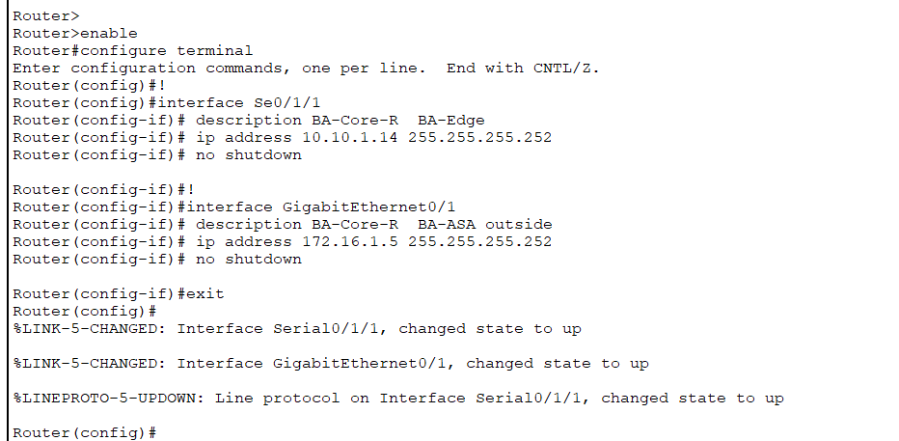

## 

## **BA-ASA**

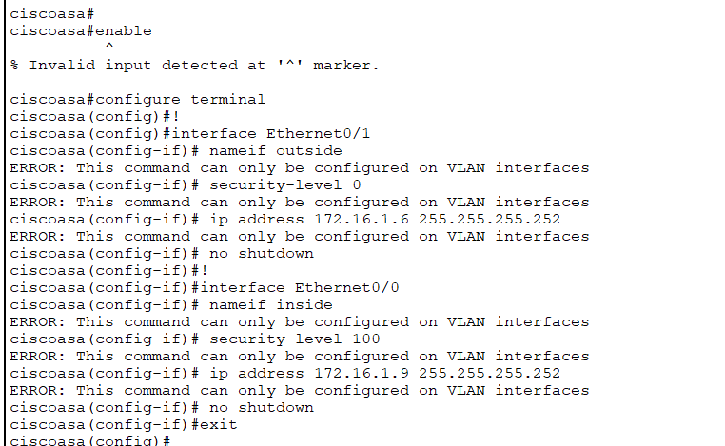

## 

## **BA-Core multilayer switch (3650-24PS)**

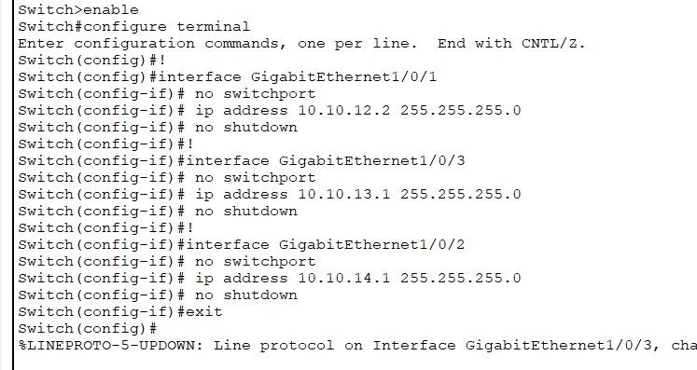

**BA-AccSW1 CLI:**

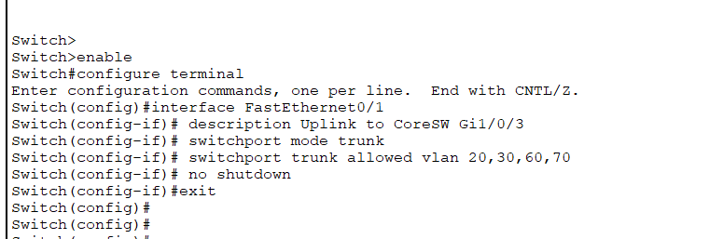

**BA-AccSW2**

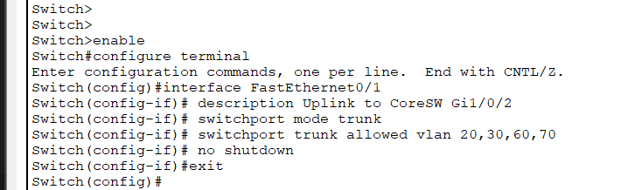

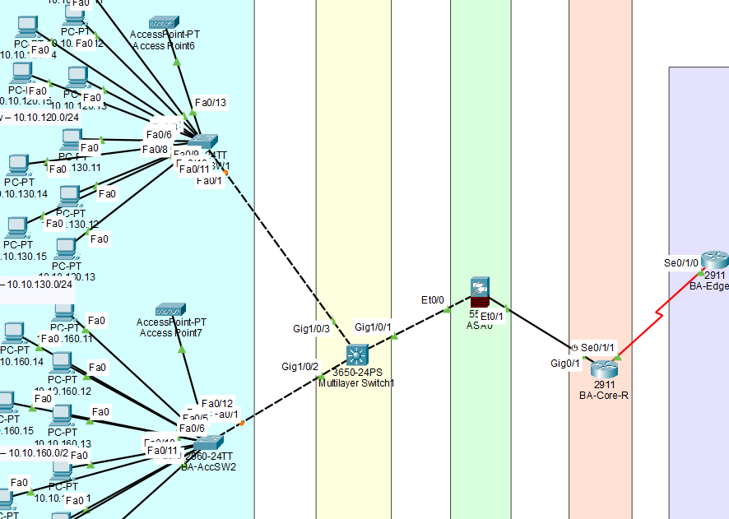

**Branch A:**

## **BB‑Edge‑R (2911)**

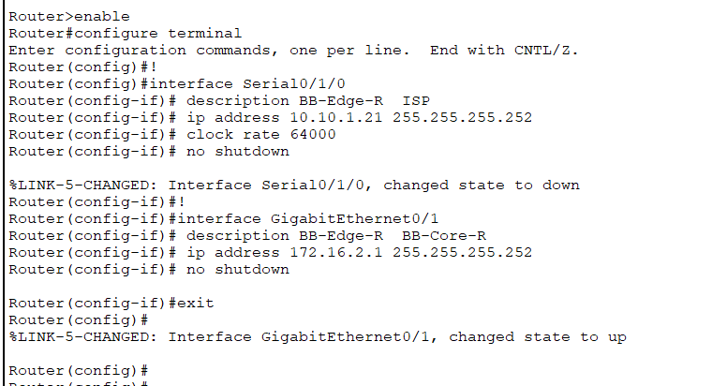

## **BB‑Core‑R (2911)**

## 

## 

## **BB‑ASA**

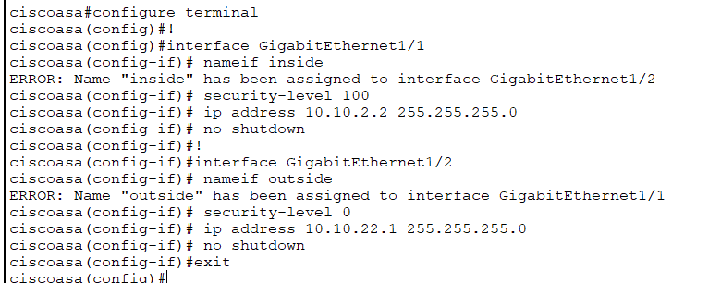

## 

## **BB‑CoreSW1 (3650-24PS)**

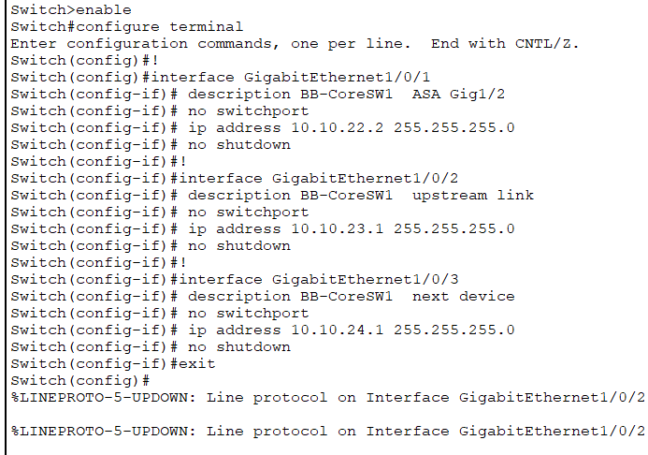

**Upper access switch**

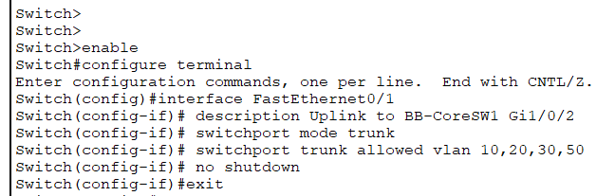

**Lower Access Switch**

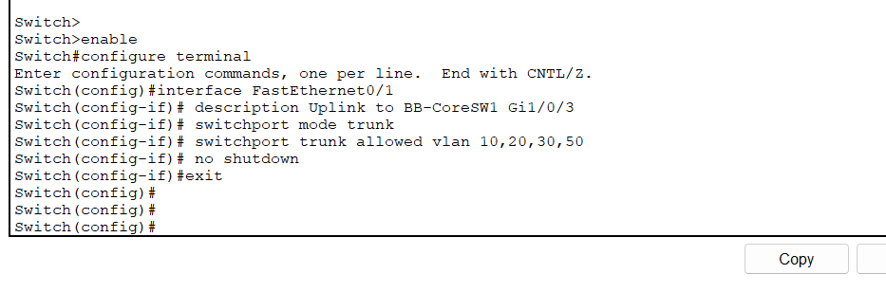

**Branch B**

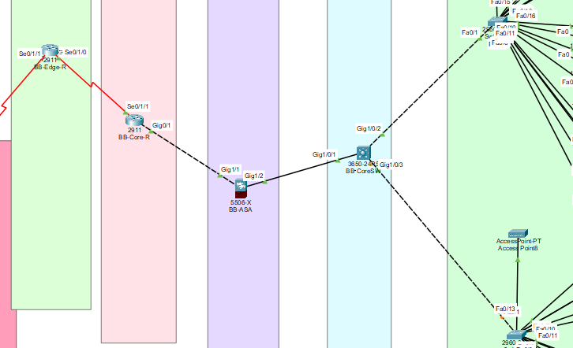

**WAN:**

**ISP‐area serial interfaces**

## **BA-Edge-R**

## **BB-Edge-R (Branch B edge)**

## 

## 

## **HQ-Edge-R1**

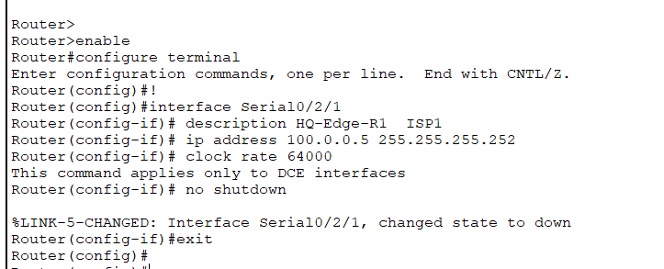

## 

## **ISP1 for HQ1**

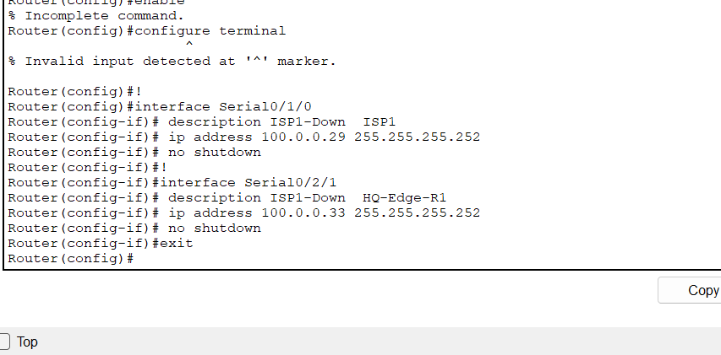

## **HQ-Edge-R2**

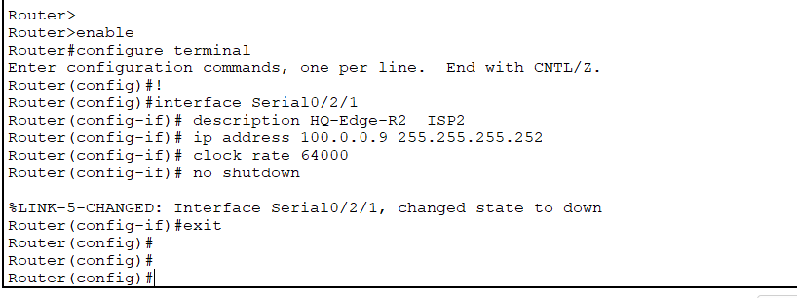

**ISP 1**

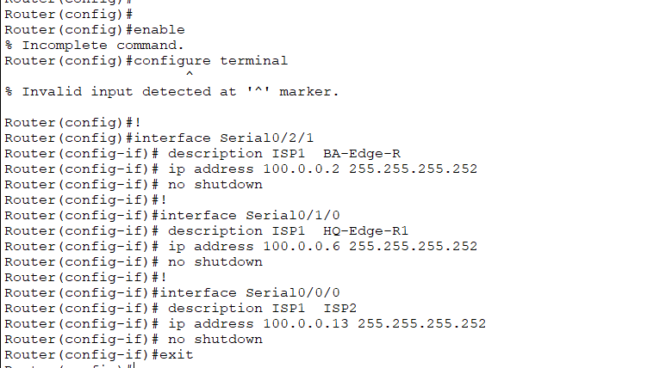

**ISP 2**

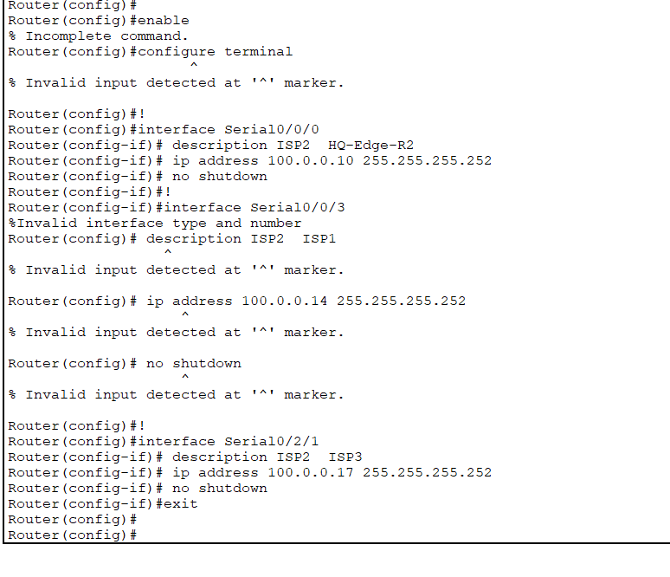

**ISP 3**

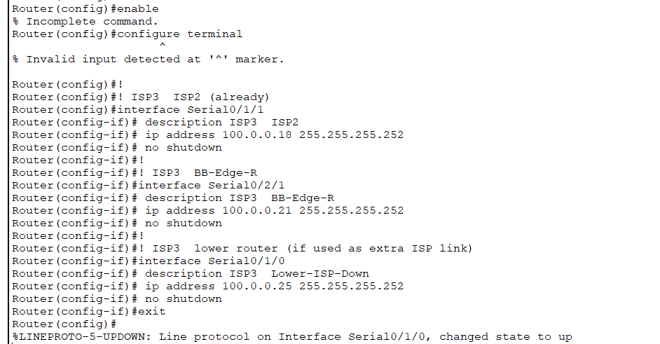

**Head Quarter :**

## **HQ‑Edge‑R1**

## 

## **HQ‑Edge‑R2**

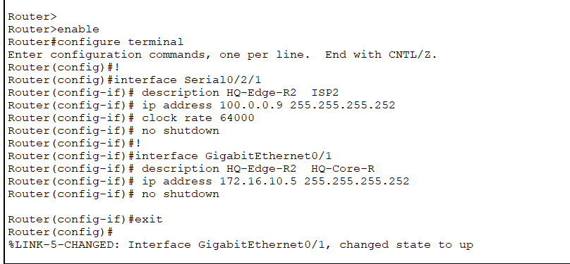

## 

## **HQ‑Core‑R**

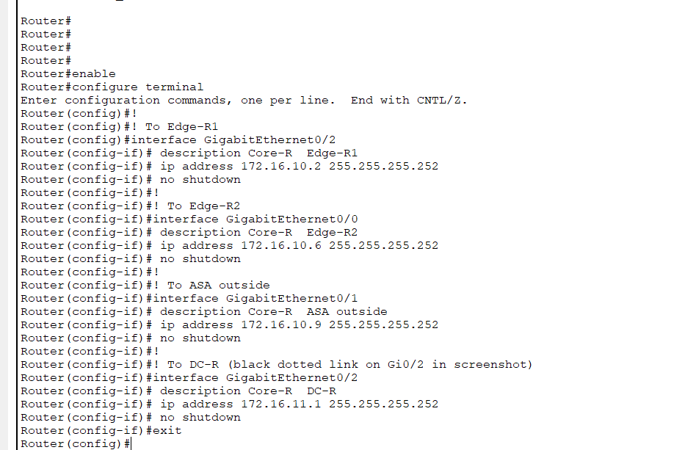

## **HQ ASA**

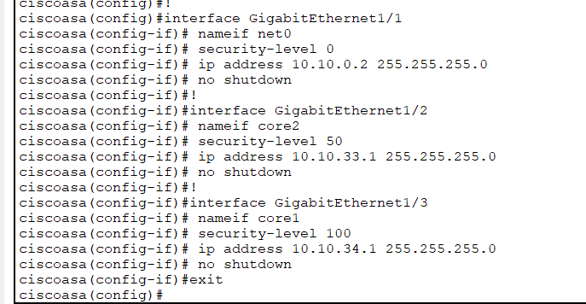

## **HQ‑CoreSW1 (left 3650, routed uplink to ASA)**

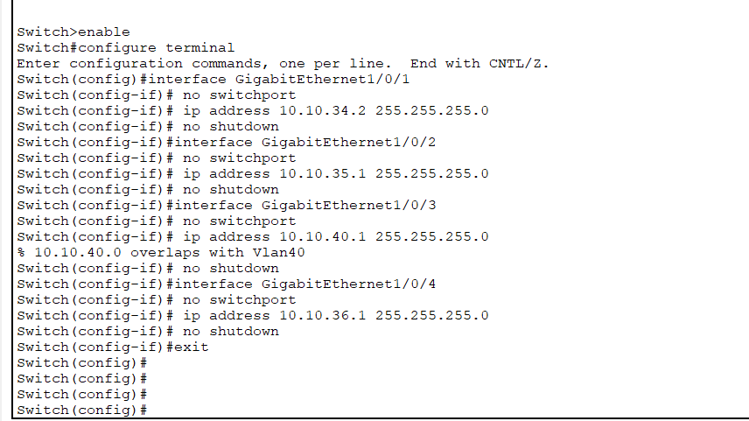

## **HQ‑CoreSW2 (right 3650, core/distribution)**

## 

## **DC‑R**

## **DC‑AccSW**

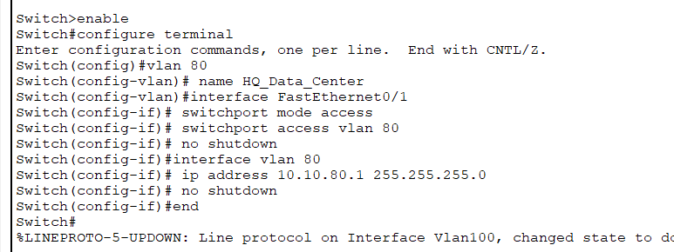

# Features in a Network

1. **VLANs:**

* **Branch A:**

**VLAN 20:**

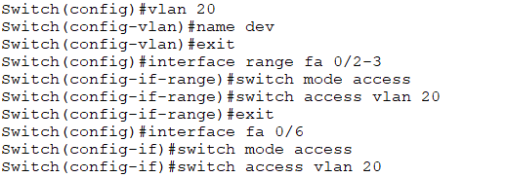

**VLAN 30:**

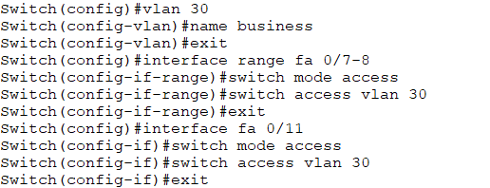

**VLAN 60:**

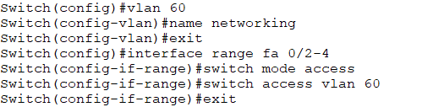

**VLAN 70:**

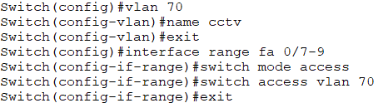

* **Branch B:**

**VLAN 10:**

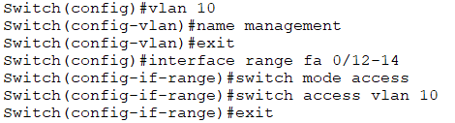

**VLAN 20:**

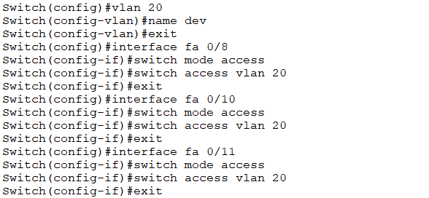

**VLAN 30:**

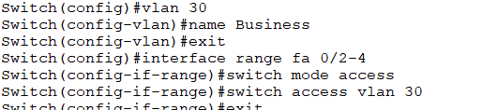

**VLAN 50:**

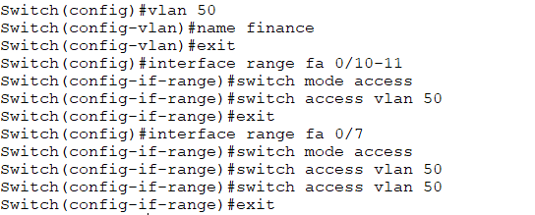

**VLAN 60:**

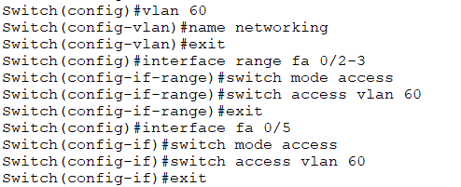

* **Head-Quarters:**

**VLAN 10:**

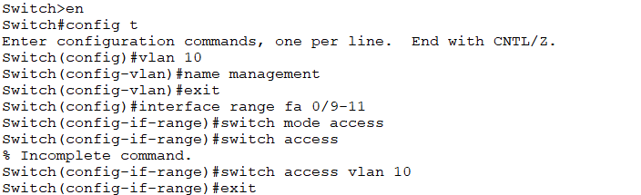

**VLAN 20:**

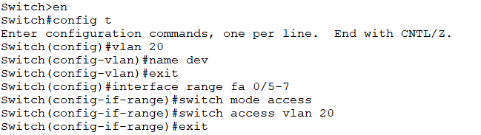

**VLAN 30:**

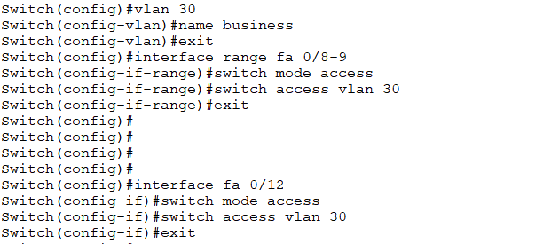

**VLAN 40:**

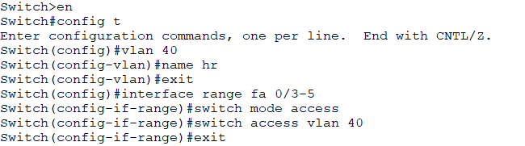

**VLAN 50:**

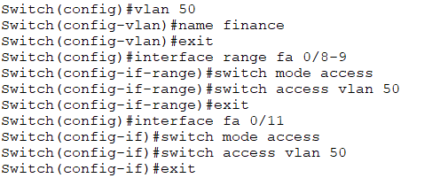

**VLAN 60:**

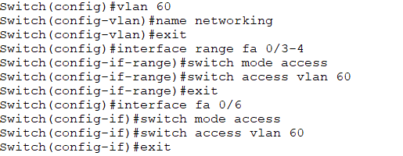

**VLAN 70:**

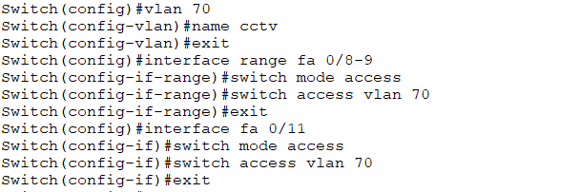

**VLAN 90:**

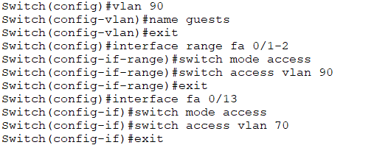

1. **Inter-VLANs using Multi-Layer Switches:**

**Branch A-MLS:**

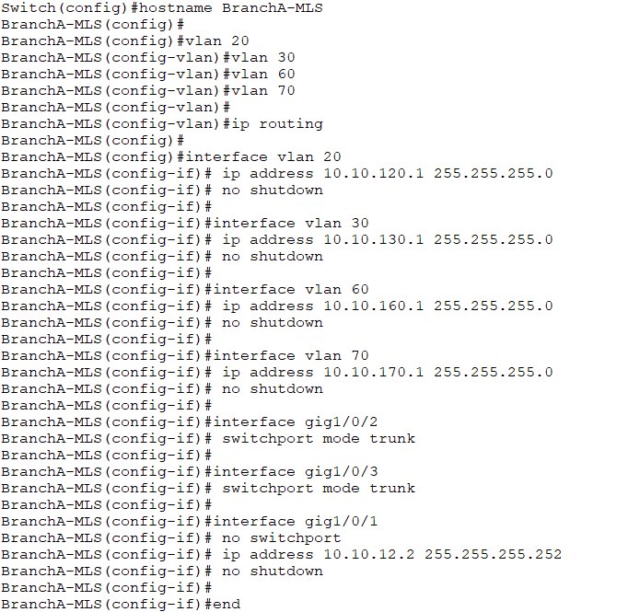

**Branch B-MLS:**

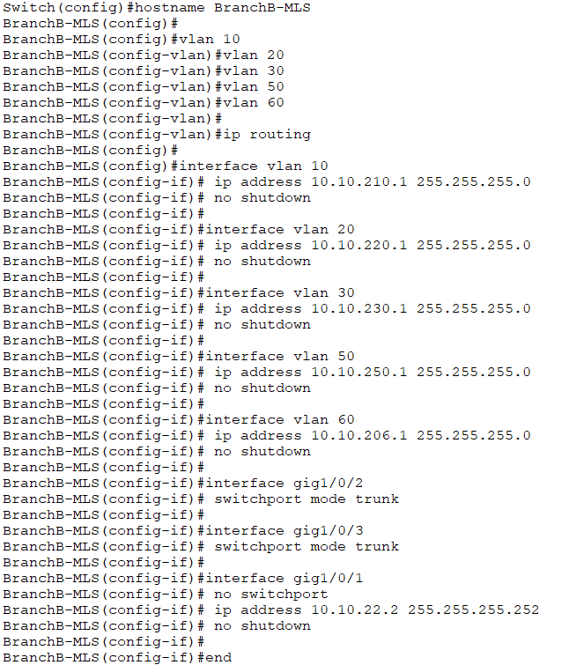

**Head Quarters:**

* **MLS1:**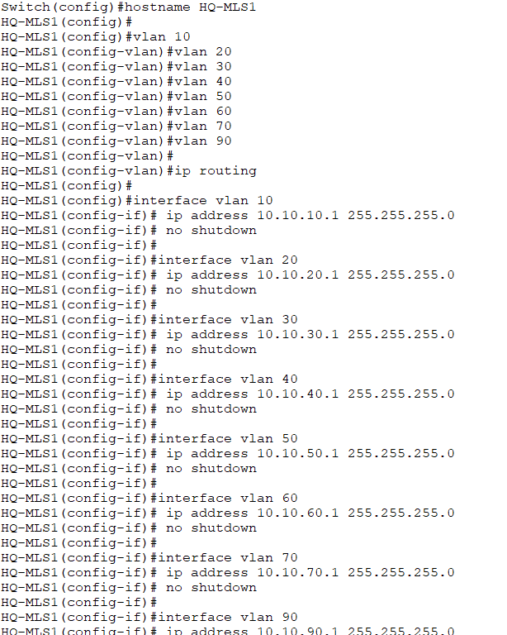
* **MLS2:**

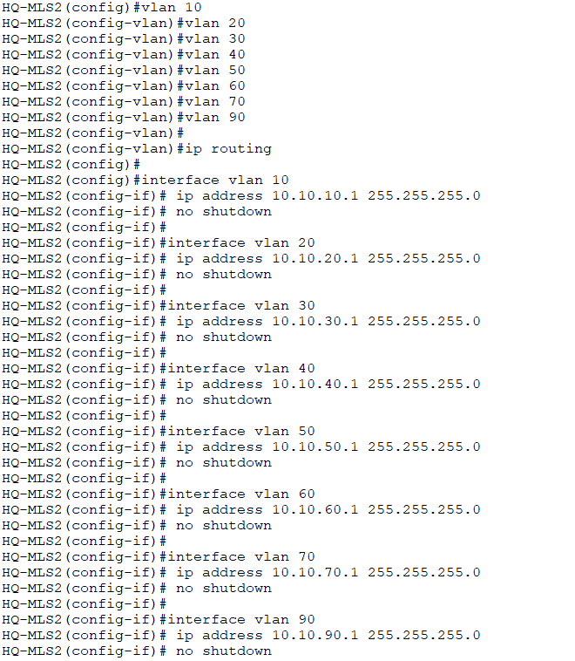

1. **HSRP between L3 Switches:**

HSRP (Hot Standby Router Protocol) is a Cisco protocol that provides a single virtual default gateway shared by multiple routers or Layer-3 switches to ensure uninterrupted network connectivity if one device fails. **L3-1:**

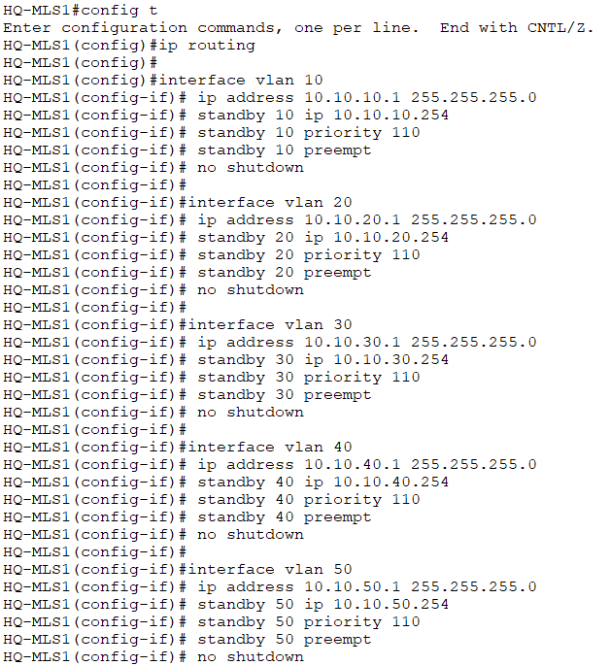

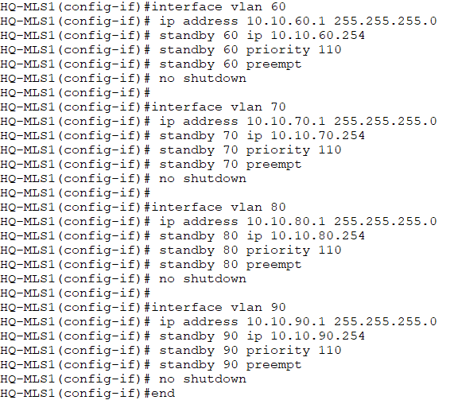

**L3-2:**

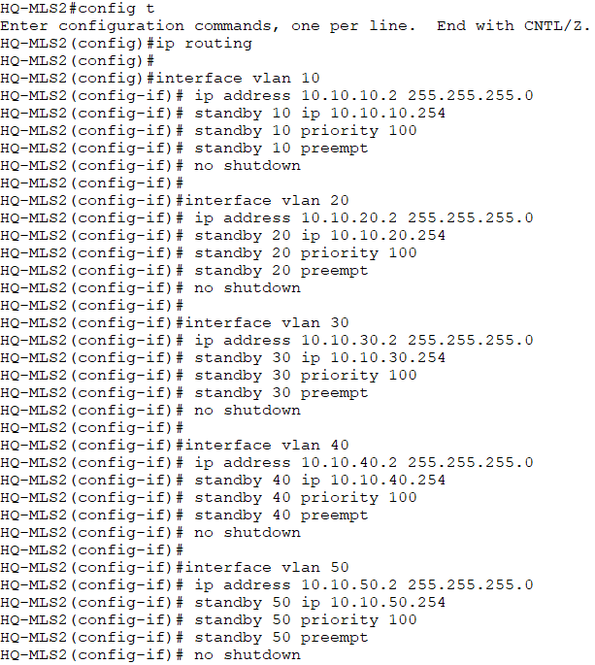

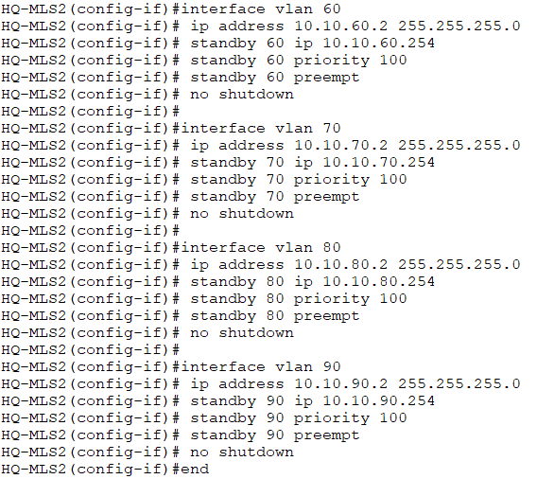

1. **ACLs Security Rules:**

**Branch A:**

Restricting the CCTV department to access the other departments except the Data centre

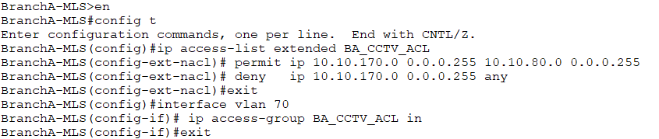

**Branch B:**

Restricting the Finance department to access the HR department directly

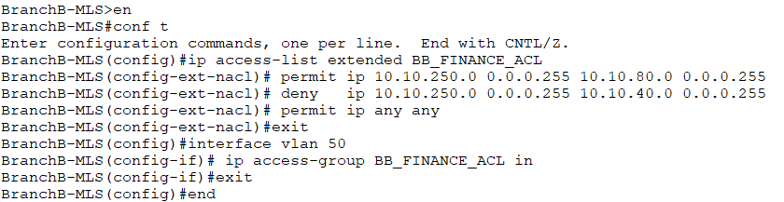

**Head Quarters:**

Restricting the Guest department to access any department in the network.

Restricting the Finance department to access the HR department directly.

Restricting the HR department to access the Finance department directly.

Restricting the CCTVs to access any department except the Data Centre.

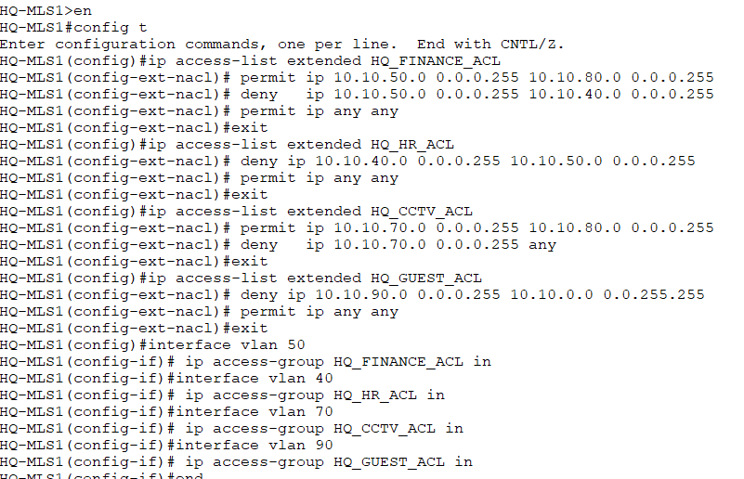

1. **Creating Zones in Firewall:**

We have created the zones in every firewall of our network so that it can manage the entering and exiting traffics of the network

**Branch A:**

Two Zones inside and outside

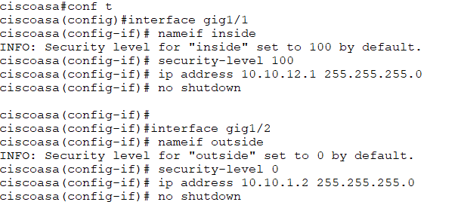

**Branch B:**

Two Zones inside and outside

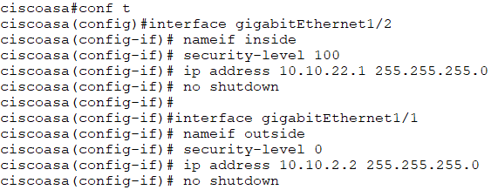

**Head Quarters:**

We have created the three zones of our firewall in HQ, one for inside traffics, second for outside traffics and the third one is for BMZ which is for the data centres

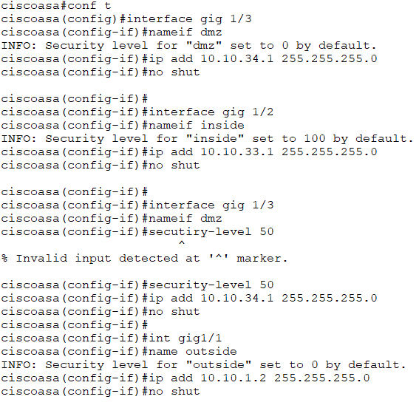

1. **Firewall Activation + NAT implementation:**

We have used a default route to communicate outside, we implemented the NAT using firewall which give our User a public ip to communicate outside and then we gave the permissions and restrictions to our Vlans

**Branch A:**

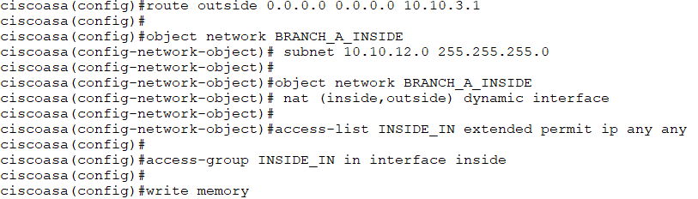

**Branch B:**

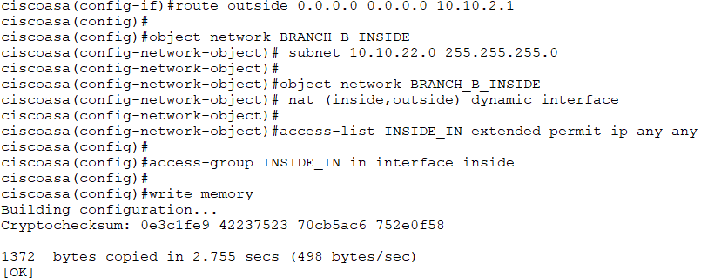

**Head Quarter:**

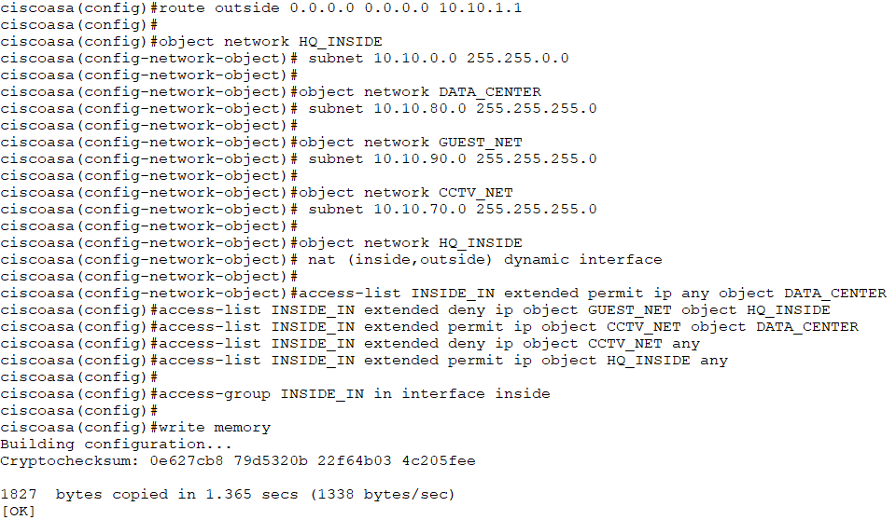

1. **Implementing the OSPF:**

On all networks [From L3 Switches > Firewall > Core Router > Edge Router]

**Ospf routes:**

HQ-Firewall:

**‘‘**As we know that firewall blocks the ospf so we created the default static routes from L3 switches to firewall and then from firewall to the core routers of the network**’’**

HQ-Core Router:

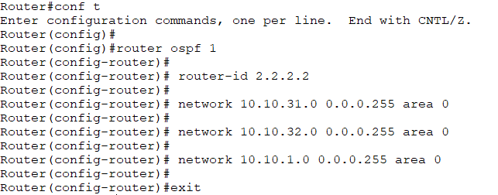

HQ-Edge Router1:

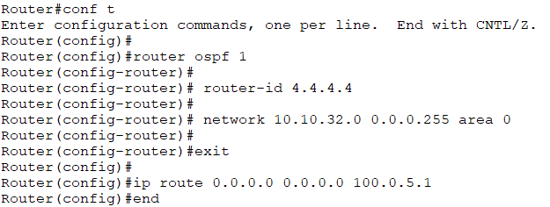

HQ-Edge Router2:

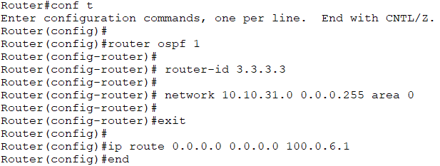

[Same Ospf in the other Branches A and B]

1. **Implementing the NAT on Firewalls:**

**HeadQuarter Firewall:**

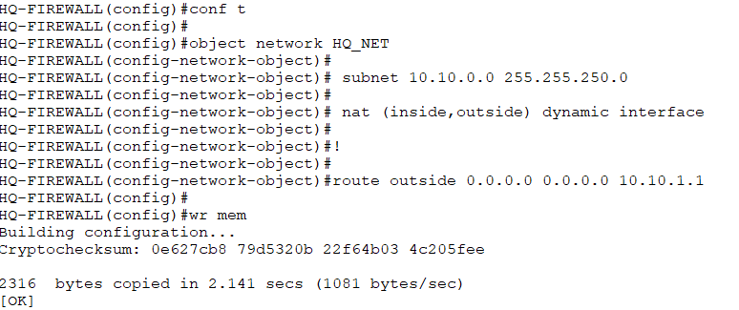

**Branch A firewall:**

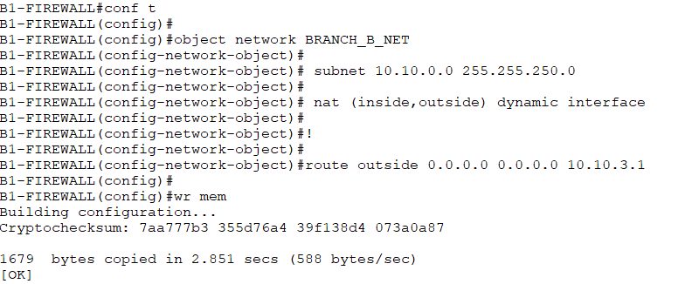

**Branch B firewall:**

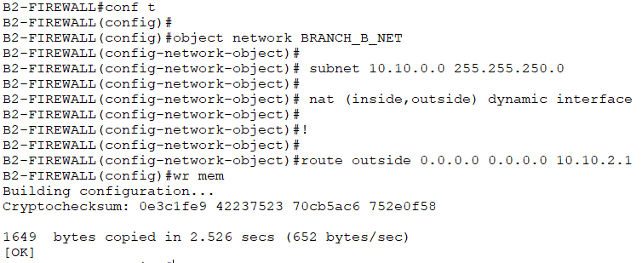

## **Server:**

# **DHCP Services Configuration**

## **for Branch B:**

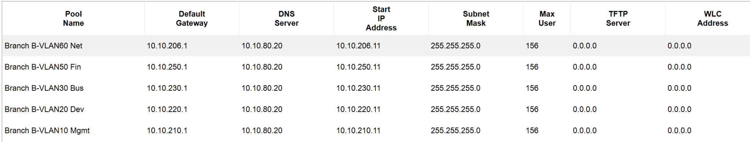

## **for Branch A:**

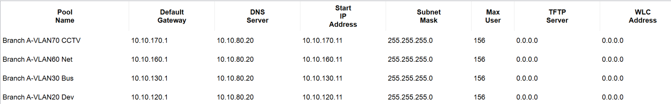

## **for Head Quarter:**

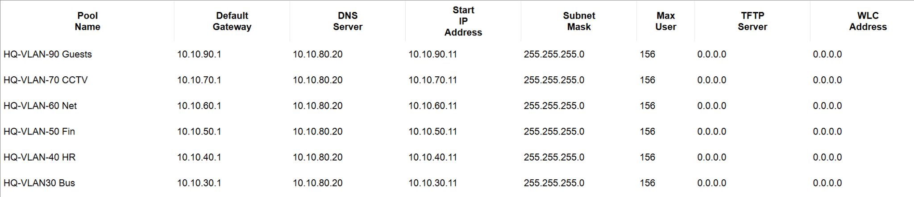

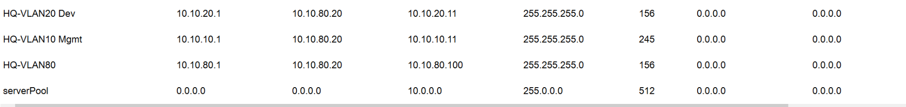

## **ICMP configured on firewall:**

**On all firewalls:**

**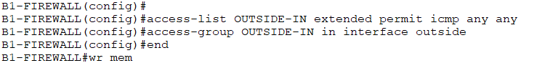  
Testing ICMP response:**

**Successful:  
